GULISTAN & TURGUT OZAL EDUCATIONAL INSTITUTIONS
INFORMATICS LESSON PLAN

DATE : DURATION: 40 minutes
GRADE LEVEL : 10th Class
SUBJECT : Standard functions - 2
OBJECTIVES : To learn how to use standard functions, Boolean Operations and Decision Statements
LESSON PLAN
Key words :
Warm-up :

Introduction and explanation of the lesson;
Example 2: Let’s see the usage of mathematical functions in an example. The following program takes the coordinates of three points of a triangle and calculates the area by using Heron’s formula. Heron's formula states that the area (A) of a triangle whose sides have lengths a, b, and c
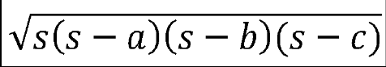

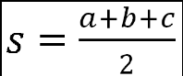
where s is half of the perimeter of the triangle:

Given the coordinates first we calculate the length of the sides by using sqrt()
and pow() functions defined in the <math> header file. Then calculate s and
calculate the area again with sqrt() function.
#include <iostream>
#include <cmath>
using namespace std;
int main()
{
int x1,x2,x3,y1,y2,y3;
float a,b,c,s,area;

cout<<"Enter the coordinates of first point :";
cin>>x1>>y1;
cout<<"Enter the coordinates of second point :";
cin>>x2>>y2;
cout<<"Enter the coordinates of third point :";
cin>>x3>>y3;

//calculate one side of triangle
a=sqrt( pow(x1-x2,2.0)+pow(y1-y2,2.0) );
//calculate one side of triangle
b=sqrt( pow(x2-x3,2.0)+pow(y2-y3,2.0) );
//calculate one side of triangle
c=sqrt( pow(x3-x1,2.0)+pow(y3-y1,2.0) );

s =(a+b+c) /2;
area = sqrt( s * (s-a) * (s-b) * (s-c) );
cout<<"\nArea is :"<<area<<endl;

system("PAUSE");
return 0;
}

(15 min) Then students are asked to write and solve the following program.

CONCLUSION:

HOMEWORK: Write a program to find out the area and volume of a sphere
Necessary formulas for this;
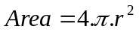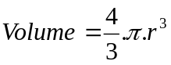

Teacher Director

